

**Task 1 – User Story Mapping**

**4067 CEM Software Design**

**Lim Sheue Ying**

**Table of Content**

1. Introduction………………………………………………………………………………… 3

2.0 Scope and Function………………………………………………………………………..3

3.0 Target Audience…………………………………………………………………………….4

4.0 User Story Map……………………………………………………………………………..7

5.0 User Story Backlog………………………………………………………………………...8

**Table of Figures**

Figure 1…………………………………………………………………………………………..4

Figure 2…………………………………………………………………………………………..5

Figure 3…………………………………………………………………………………………..5

Figure 4…………………………………………………………………………………………..6

Figure 5…………………………………………………………………………………………..6

Figure 6…………………………………………………………………………………………...7

**1.0 Introduction**

In today's dynamic and competitive world, college students are increasingly embracing entrepreneurship as a means to showcase their skills, explore their passions, and create opportunities. To support their entrepreneurial journey, the development of a Student Business System becomes paramount. This project aims to create a comprehensive digital platform that caters specifically to the needs of college students engaged in business activities, providing them with the necessary tools and resources to thrive in their entrepreneurial ventures while balancing their academic commitments.

**2.0 Scope and Function**

The Student Business System is proposed as a centralized platform that offers a wide range of functionalities and features tailored to the unique requirements of college student entrepreneurs. It serves as a one-stop solution, assisting students in various aspects of business management, such as inventory tracking, financial management, marketing, appointment scheduling, collaboration, and analytics.

The system aims to streamline and simplify business operations, allowing students to focus on their core competencies and business growth. By incorporating user-friendly interfaces, intuitive navigation, and seamless integration with external platforms and services, the system empowers college students to efficiently manage their businesses while balancing their academic commitments.

With the Student Business System, college students can benefit from a holistic suite of tools designed to enhance their entrepreneurial journey. The system enables them to track and manage inventory, monitor financials, create professional invoices, conduct social media marketing, schedule appointments, collaborate with team members, and analyze business performance. By consolidating these features into a single platform, the Student Business System aims to provide convenience, efficiency, and effectiveness in managing and growing student-led businesses.

**3.0 Target Audience**

The Student Business System is designed to cater to the needs of college students who are engaged in various entrepreneurial ventures. In order to gain insights into the specific requirements of our target audience, we conducted a Google Form survey, collecting feedback from 10 students about their expectations and what they desire in a Student Business System.

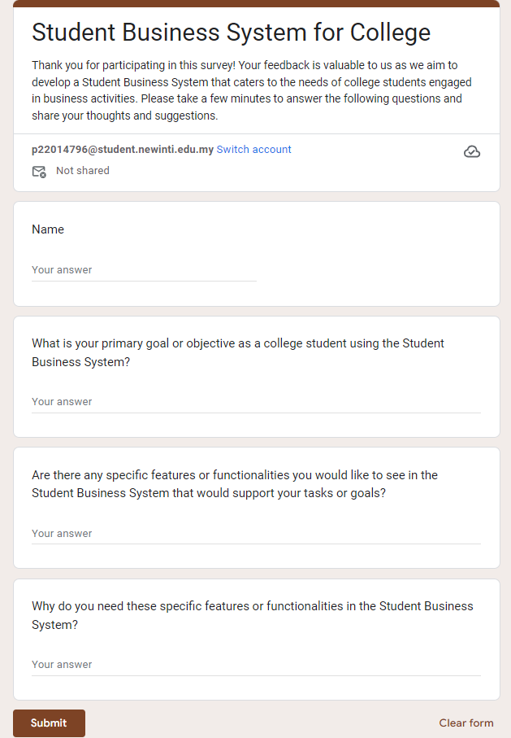

Figure 1: Questions provided in Google Form Survey

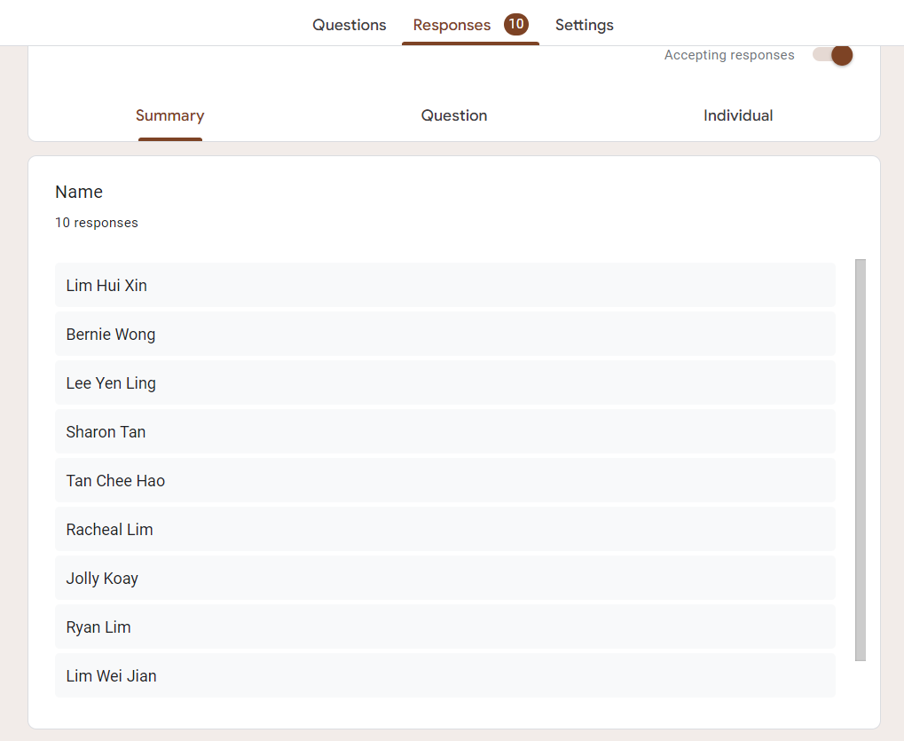

Figure 2: Names of the respondents

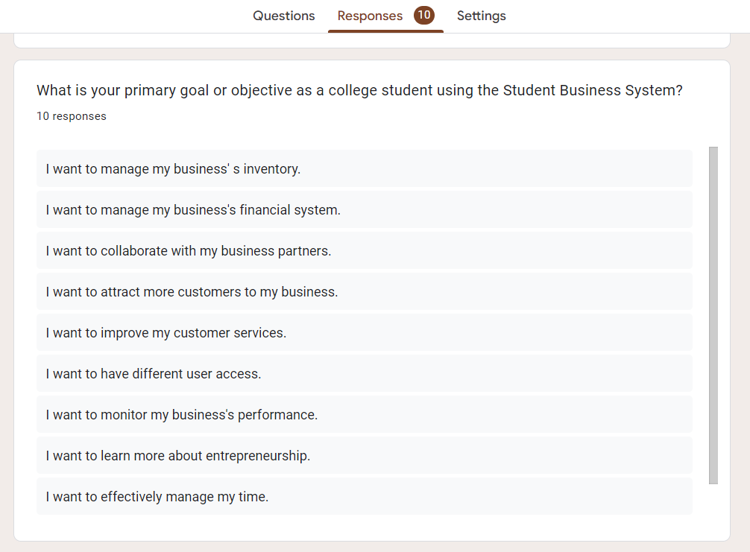

Figure 3: Feedbacks collected

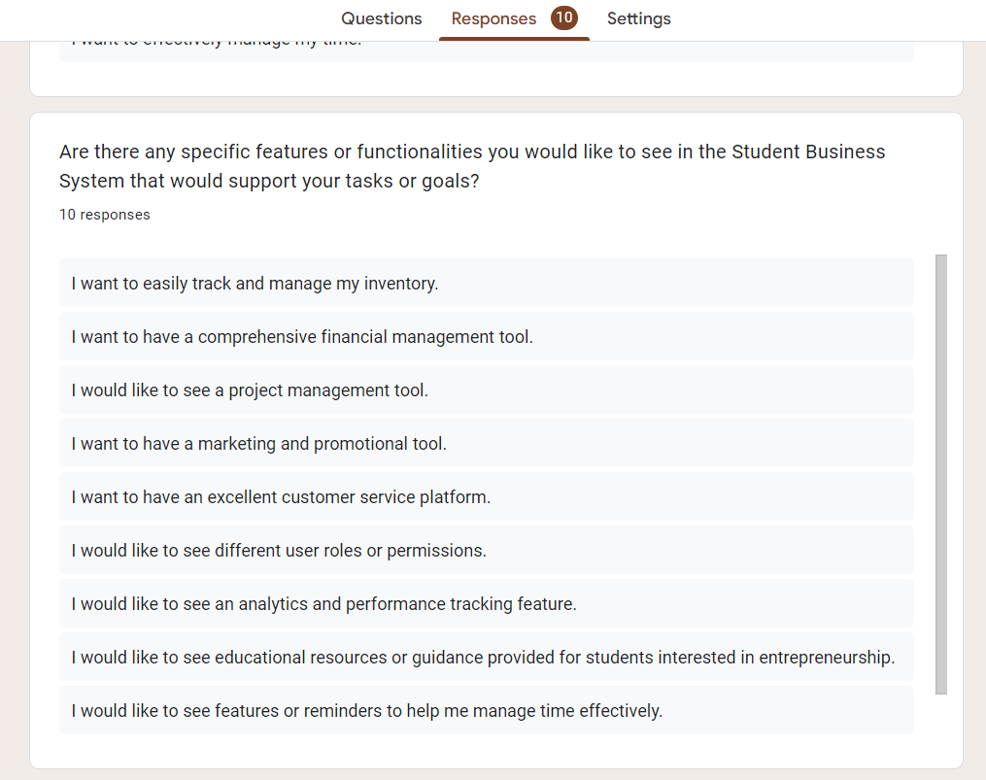

Figure 4: Feedbacks collected

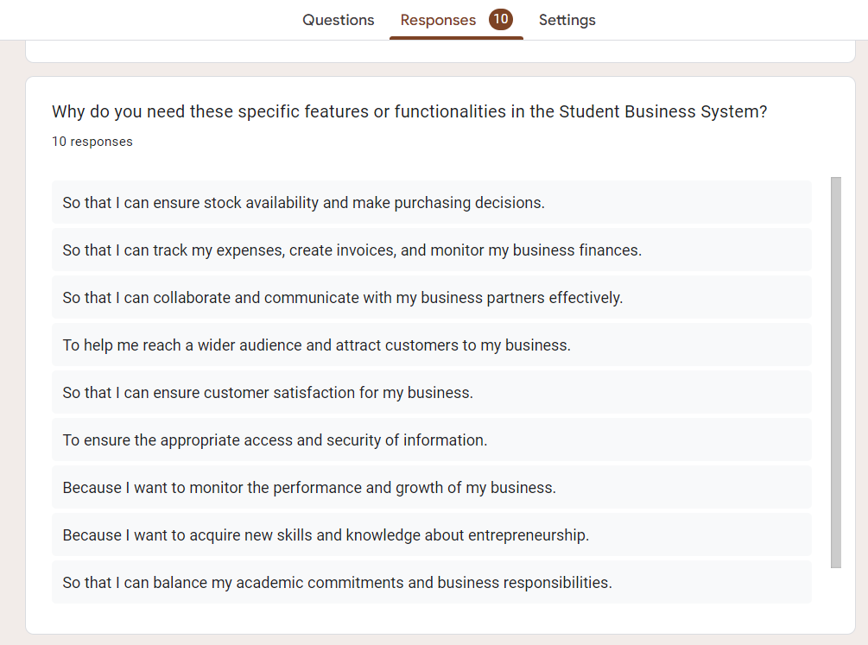

Figure 5: Feedbacks collected

**4.0 User Story Map**

In this section, the user story map for the Student Business System is presented based on the data collected through the Google Form Survey. I used Figma, a collaborative design tool that enables the creation of interactive and visually appealing user interfaces to create this user story map. The user story map consists of goals, tasks, and releases.

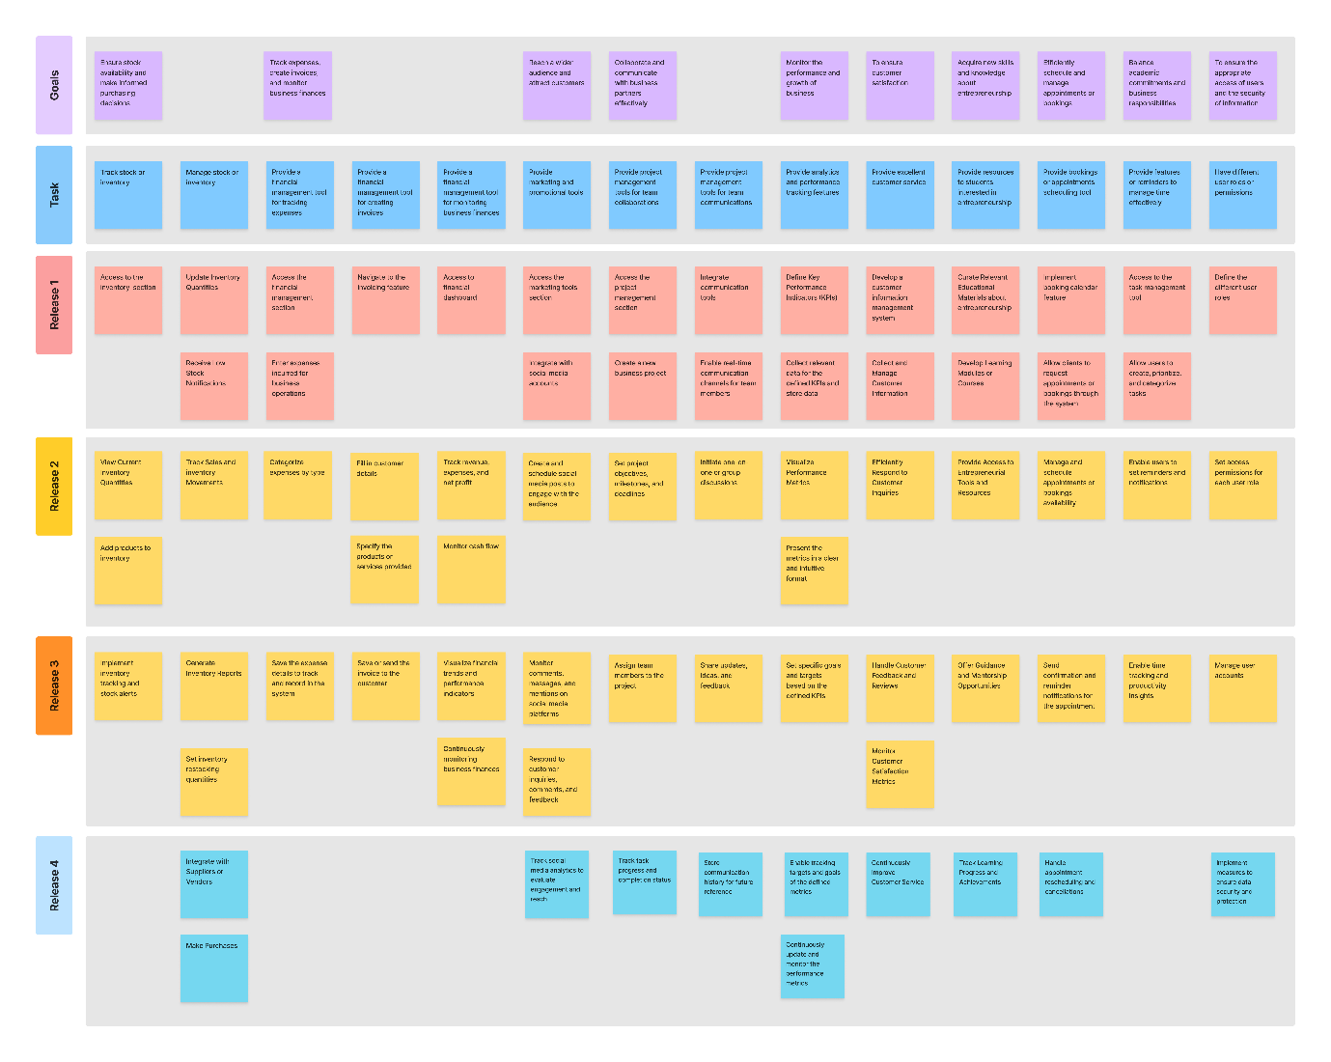

Figure 6: User Story Maps for the Student Business System

**5.0 User Story Backlog**

**User Story 1**: As a user, I want the Student Business System to easily track and manage my inventory so that I can ensure stock availability and make purchasing decisions.

Goals: Ensure stock availability and make purchasing decisions

Task 1: Track stock or inventory

Releases:

1. Access to the inventory management section.
2. View the current inventory, including product quantities, and other relevant details.
3. Add products to inventory.
4. Implement inventory tracking and stock alerts.

Task2: Manage stock or inventory

Releases:

1. Update Inventory Quantities.
2. Receive Low Stock Notifications.
3. Track Sales and Stock Movements.
4. Generate Inventory Reports.
5. Set inventory restocking quantities.
6. Integrate with Suppliers or Vendors
7. Make purchases.

This user story map outlines the goals, tasks, and releases for inventory tracking and management. Accessing the inventory management system, viewing and adding products to inventory, implementing inventory tracking and stock alerts, generating inventory reports, setting inventory restocking quantities, and integrating with suppliers or vendors will enable users to efficiently manage their inventory, ensure stock availability, and make purchasing decisions.

**User Story 2**: As a user, I want the Student Business System to have a comprehensive financial management tool so that I can track my expenses, create invoices, and monitor my business finances.

Goals: Track expenses, create invoices, and monitor business finances

Task 1: Provide a financial management tool for tracking expenses

Releases:

1. Access to the financial management section in the Student Business System.
2. Enter expenses incurred for business operations
3. Categorize expenses by type
4. Save the expense details to track and record in the system

Task 2: Provide a financial management tool for creating invoices

Releases:

1. Navigate to the invoicing feature in the Student Business System.
2. Fill in customer details, such as name, address, and contact information.
3. Specify the products or services provided.
4. Save or send the invoice to the customer.

Task 3: Provide a financial management tool for monitoring business finances

Releases:

1. Access to the financial dashboard in the Student Business System.
2. Track revenue, expenses, and net profit.
3. Monitor cash flow, including incoming and outgoing transactions.
4. Visualize financial trends and performance indicators.
5. Continuously monitoring business finances.

This user story map outlines the goals, tasks, and releases for the comprehensive financial management tool within the Student Business System. By following these steps, users can effectively track expenses, create invoices, and monitor finances.

**User Story 3**: As a user, I want the Student Business System to provide marketing and promotional tools to help me reach a wider audience and attract customers to my business.

Goals: Reach a wider audience and attract customers

Task 1: Provide marketing and promotional tools

Releases:

1. Access the marketing tools section within the Student Business System.
2. Integrate social media accounts (e.g., Facebook, Instagram, Twitter).
3. Create and schedule social media posts to engage with the audience.
4. Monitor comments, messages, and mentions on social media platforms.
5. Respond to customer inquiries, comments, and feedback.
6. Track social media analytics to evaluate engagement and reach.

This user story map outlines the goals, tasks, and releases for marketing and promotional tools within the Student Business System. By following these steps, users can create and effectively manage their social media presence, track marketing performance, and provide customer feedback channels to attract customers and grow their businesses.

**User Story 4**: As a user, I want the Student Business System to have project management tools so that I can collaborate and communicate with my business partners effectively.

Goals: Collaborate and communicate with business partners effectively

Task 1: Provide project management tools for team collaborations

Releases:

1. Access the project management section within the Student Business System.
2. Create a new project, specifying its name, description, and relevant details.
3. Set project objectives, milestones, and deadlines.
4. Assign team members to the project.
5. Track task progress and completion status.

Task 2: Provide project management tools for team communications

Releases:

1. Integrate communication tools (e.g., chat, messaging, video conferencing) within the Student Business System.
2. Enable real-time communication channels for team members.
3. Initiate one-on-one or group discussions for effective collaboration.
4. Share updates, ideas, and feedback in real-time.
5. Store communication history for future reference.

This user story map outlines the goals, tasks, and releases for collaboration and communication within the Student Business System. By following these steps, users can effectively create and manage team projects, assign and track tasks, share and store documents, and facilitate real-time communication with their business partners.

**User Story 5**: As a user, I want the Student Business System to offer analytics and performance tracking features to monitor the performance and growth of my business.

Goals: Monitor the performance and growth of business

Task: Provide analytics and performance-tracking features

Release:

1. Identify the key metrics and performance indicators (KPIs) that are relevant for measuring the performance and growth of the business.
2. Implement data collection mechanisms within the Student Business System to gather relevant data for the defined KPIs and store the data.
3. Design visual representations, such as charts or graphs, to display the performance metrics.
4. Present the metrics in a clear and intuitive format for easy understanding and analysis.
5. Set specific goals and targets based on the defined KPIs.
6. Enable tracking targets and goals of the defined metrics.
7. Continuously update and monitor the performance metrics.

This user story map outlines the goals, tasks, and releases for analytics and performance tracking within the Student Business System. By following these steps, college student business owners can collect and analyze data, generate key performance indicators, visualize data and reports, set goals and targets, track business metrics, identify trends and patterns, and make data-driven decisions to monitor the success and growth of their businesses.

**User Story 6**: As a user, I want the Student Business System to provide excellent customer service to ensure customer satisfaction for my business.

Goals: Ensure customer satisfaction

Task 1: Provide excellent customer service

Release:

1. Develop a customer information management system.
2. Collect and Manage Customer Information.
3. Efficiently Respond to Customer Inquiries.
4. Handle Customer Feedback and Reviews.
5. Monitor Customer Satisfaction Metrics
6. Continuously Improve Customer Service.

This user story map outlines the goals, tasks, and releases for providing excellent customer service within the college student business. By following these steps, users can collect customer information, respond to inquiries, handle feedback and reviews, monitor customer satisfaction metrics, and continuously improve their customer service to ensure the satisfaction of customers.

**User Story 7**: As a user, I want the Student Business System to provide educational resources or guidance for students interested in entrepreneurship, helping them to acquire new skills and knowledge about entrepreneurship.

Goals: Acquire new skills and knowledge about entrepreneurship

Task 1: Provide resources to students interested in entrepreneurship

Release:

1. Curate relevant Educational Materials about entrepreneurship.
2. Develop Learning Modules or Courses.
3. Provide Access to Entrepreneurial Tools and Resources.
4. Offer Guidance and Mentorship Opportunities.
5. Track Learning Progress and Achievements.

This user story map outlines the goals, tasks, and releases for providing educational resources and guidance for students interested in entrepreneurship within the Student Business System. By curating relevant educational materials, developing learning modules or courses, providing access to entrepreneurial tools and resources, offering guidance and mentorship opportunities, and tracking learning progress and achievements, the system aims to support college student business owners in acquiring new skills and knowledge for their entrepreneurial endeavors.

**User Story 8**: As a user, running a service-based business using the Student Business System, I want to have a booking or appointment scheduling tool so that I can efficiently schedule and manage appointments or bookings.

Goals: Efficiently schedule and manage appointments or bookings

Task 1: Provide bookings or appointments scheduling tool

Release:

1. Implement a booking calendar feature.
2. Allow clients to request appointments or bookings through the system.
3. Manage and schedule appointments or bookings availability.
4. Send confirmation and reminder notifications for the appointment.
5. Handle appointment rescheduling and cancellations.

This user story map outlines the goals, tasks, and releases for implementing an appointment scheduling tool within the Student Business System. By implementing a booking calendar, enabling client appointment requests, managing availability and scheduling, sending confirmation and reminder notifications, and handling rescheduling and cancellations, users can efficiently schedule and manage appointments or bookings.

**User Story 9**: As a user, I want the Student Business System to provide features or reminders to help me manage my time effectively so that I can balance my academic commitments and business responsibilities.

Goals: Balance academic commitments and business responsibilities

Task: Provide features or reminders to manage time effectively

Releases:

1. Access to the task management tool.
2. Allow users to create, prioritize, and categorize tasks.
3. Enable users to set reminders and notifications.
4. Enable time tracking and productivity insights to help users identify areas for improvement and optimize their time management.

This user story map outlines the goals, tasks, and releases for time management features within the Student Business System. Creating, prioritizing, and categorizing tasks, setting reminders and notifications systems, and enabling time tracking and productivity insights will empower users to effectively manage their time, balance academic and business responsibilities, and achieve better productivity and work-life harmony.

**User Story 10**: As a college student using the Student Business System, I want to have different user roles or permissions, such as a business owner, team member, or customer, to ensure the appropriate access and security of information.

Goals: To ensure the appropriate access of users and the security of information

Task: Have different user roles or permissions

Releases:

1. Define the different user roles.
2. Set access permissions for each user role.
3. Manage user accounts.
4. Implement measures to ensure data security and protection.

This user story map outlines the goals, tasks, and releases for different user roles and permissions within the Student Business System. Implementing defined user roles, setting access permissions, managing user accounts, and maintaining data security in the user experience will ensure appropriate access, enhance information security, and provide a tailored experience for each user within the system.